<http://data.01caijing.com/p2p/index.html>

有4096个平台，有所需的完整数据的估计是2000多个。

爬的平台数量越多越好，如果不方便的话，至少爬500个平台，名单附在后面（待补充）。

比如 红岭创投：

<http://data.01caijing.com/p2p/website/platform-details-12410.html>

抓取红框中的数据：包括“成交指标、利率指标、期限指标、借款人数量、人均借款额、投资人数量、人均投资额、贷款余额”等8项指标

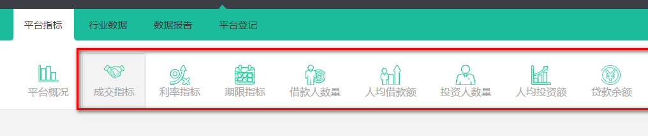

比如 **成交指标**：

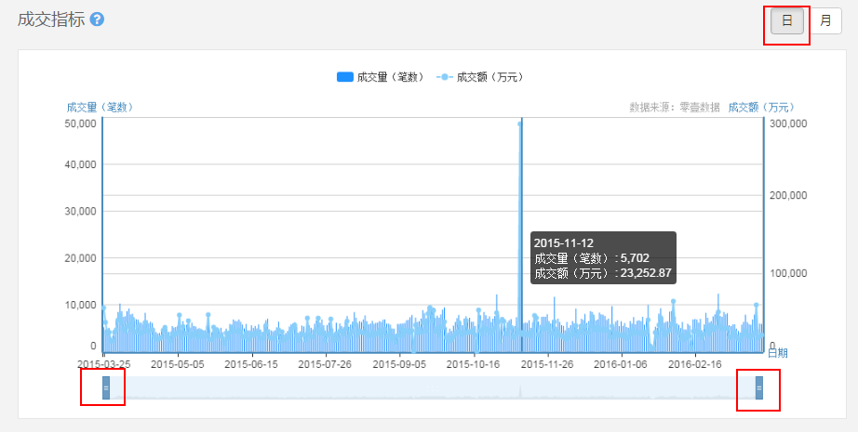

* 选择右上方“日”，只需要频率为“**日**”的数据。
* 注意下方时间条两端都要拖到头；（绝大部分平台的指标时间从2015-03-25至2016-03-24，也就是最近一年的时间。但有的平台的交易时间会短于这个期间，将两端拖到头即可）
* 鼠标移动到条形图上时会有 成交量和成交额；
* 需要抓取 （时间，成交量，成交额） 保存到 excel /txt/csv文件均可
* 然后对“利率指标、期限指标、借款人数量、人均借款额、投资人数量、人均投资额、贷款余额”等指标，**重复以上操作**，获取不同的指标数据。

**同一个平台的指标数据保存到一个文档里，如果是放在excel或csv的话，可以一个文档里放N个sheet，每一个sheet放一个平台的数据：**



如果全部几百个平台放一个excel或csv文件的话可能会太大，可以适当地分为不同的文件，比如一个excel或csv放30~50个sheet。

* 最后，每个平台的指标包括：

时间、成交量（笔数）、成交额（万元）、利率指标（%）、平均借款期限（天）、借款人数量（人/次）、人均借款额 投资人数量（人）、人均投资额（万元）、还款余额（万元）、待还金额（万元）

示例：



**具体形式参见excel示例文件**

平台有的是有数据，有的没有，有数据的总共估计1000多；所以最好是能把有数据的平台抓下来；

如果不方便，可以再手动整理出平台名单，待定！

**附**：**部分名单**

365金融 http://data.01caijing.com/p2p/website/index-12100.html

808信贷 http://data.01caijing.com/p2p/website/index-13100.html

91快车 http://data.01caijing.com/p2p/website/index-13504.html

e租宝 http://data.01caijing.com/p2p/website/index-12624.html

爱定投 http://data.01caijing.com/p2p/website/index-14481.html

安穗金融 http://data.01caijing.com/p2p/website/index-17664.html

百事得财富 http://data.01caijing.com/p2p/website/index-17292.html

滨学贷 http://data.01caijing.com/p2p/website/index-17300.html

渤海创投 http://data.01caijing.com/p2p/website/index-14543.html

渤海金融 http://data.01caijing.com/p2p/website/platform-details-14746.html

财富宝 http://data.01caijing.com/p2p/website/index-13059.html

财源网 http://data.01caijing.com/p2p/website/index-11853.html

车贷汇 http://data.01caijing.com/p2p/website/index-13459.html

车当铺 http://data.01caijing.com/p2p/website/index-17386.html

楚商创投 http://data.01caijing.com/p2p/website/index-13152.html

春鹏易贷 http://data.01caijing.com/p2p/website/index-14580.html

贷乐网 http://data.01caijing.com/p2p/website/index-13124.html

燈融创投 http://data.01caijing.com/p2p/website/index-12570.html

第四市场 http://data.01caijing.com/p2p/website/index-12384.html

东起投资 http://data.01caijing.com/p2p/website/index-13383.html

多多智富 http://data.01caijing.com/p2p/website/index-12907.html

多好贷 http://data.01caijing.com/p2p/website/index-17695.html

发利网 http://data.01caijing.com/p2p/website/index-17544.html

方圆财富 http://data.01caijing.com/p2p/website/index-14274.html

福润融通 http://data.01caijing.com/p2p/website/index-12577.html

富达亚金融 http://data.01caijing.com/p2p/website/index-12636.html

富裕财富 http://data.01caijing.com/p2p/website/index-14530.html

富源创投 http://data.01caijing.com/p2p/website/index-13576.html

感投网 http://data.01caijing.com/p2p/website/index-11877.html

公务贷 http://data.01caijing.com/p2p/website/index-13464.html

广安宏润 http://data.01caijing.com/p2p/website/index-13021.html

国湘资本 http://data.01caijing.com/p2p/website/index-13888.html

汉商贷 http://data.01caijing.com/p2p/website/index-13309.html

好借好贷（苏） http://data.01caijing.com/p2p/website/index-12286.html

好时代 http://data.01caijing.com/p2p/website/index-13447.html

黑火金融 http://data.01caijing.com/p2p/website/index-13761.html

恒通金融 http://data.01caijing.com/p2p/website/index-17176.html

弘利创投 http://data.01caijing.com/p2p/website/index-17187.html

红顶财富 http://data.01caijing.com/p2p/website/index-17595.html

宏阳财富 http://data.01caijing.com/p2p/website/index-12180.html

泓润恒业 http://data.01caijing.com/p2p/website/index-13331.html

互融城 http://data.01caijing.com/p2p/website/index-17293.html

华友创投 http://data.01caijing.com/p2p/website/index-12613.html

汇利通 http://data.01caijing.com/p2p/website/index-14483.html

汇龙贷 http://data.01caijing.com/p2p/website/index-13238.html

汇纳财富 http://data.01caijing.com/p2p/website/index-666444.html

汇鑫益 http://data.01caijing.com/p2p/website/index-14304.html

惠卡贷 http://data.01caijing.com/p2p/website/index-13743.html

集优贷 http://data.01caijing.com/p2p/website/index-12006.html

加诚金融 http://data.01caijing.com/p2p/website/index-17413.html

金钱橘 http://data.01caijing.com/p2p/website/index-14334.html

金线财富 http://data.01caijing.com/p2p/website/index-17430.html

久鼎创投 http://data.01caijing.com/p2p/website/interest-12234.html

聚德贷 http://data.01caijing.com/p2p/website/index-17166.html

聚福银汇 http://data.01caijing.com/p2p/website/index-17303.html

聚投融 http://data.01caijing.com/p2p/website/index-13604.html

懒人财富 http://data.01caijing.com/p2p/website/index-12734.html

乐投资 http://data.01caijing.com/p2p/website/index-12339.html

理财邦 http://data.01caijing.com/p2p/website/index-13615.html

利商贷 http://data.01caijing.com/p2p/website/index-12856.html

连云港e贷 http://data.01caijing.com/p2p/website/index-11753.html

联汇金融 http://data.01caijing.com/p2p/website/index-13924.html

联正金融 http://data.01caijing.com/p2p/website/index-13940.html

林登财富 http://data.01caijing.com/p2p/website/index-17356.html

领峰金融 http://data.01caijing.com/p2p/website/index-13380.html

鲁家所 http://data.01caijing.com/p2p/website/index-17229.html

鲁融贷 http://data.01caijing.com/p2p/website/index-13291.html

麦钱 http://data.01caijing.com/p2p/website/index-17537.html

么么哒理财 http://data.01caijing.com/p2p/website/index-14717.html

苗木之家 http://data.01caijing.com/p2p/website/index-12846.html

秒淼财富 http://data.01caijing.com/p2p/website/index-14744.html

民商理财 http://data.01caijing.com/p2p/website/index-13554.html

诺辰财富 http://data.01caijing.com/p2p/website/index-12860.html

诺信创投 http://data.01caijing.com/p2p/website/index-11982.html

朋友贷 http://data.01caijing.com/p2p/website/index-11941.html

票金所 http://data.01caijing.com/p2p/website/index-14529.html

钱根源 http://data.01caijing.com/p2p/website/index-12769.html

乾龙在线 http://data.01caijing.com/p2p/website/index-12494.html

全诚在线 http://data.01caijing.com/p2p/website/index-13172.html

荣桓世远 http://data.01caijing.com/p2p/website/index-14263.html

融彬贷 http://data.01caijing.com/p2p/website/index-17251.html

融途天下 http://data.01caijing.com/p2p/website/index-17195.html

商会易贷 http://data.01caijing.com/p2p/website/index-12366.html

尚佳财富 http://data.01caijing.com/p2p/website/index-12521.html

申融财富 http://data.01caijing.com/p2p/website/index-14474.html

神州通宝 http://data.01caijing.com/p2p/website/index-11972.html

胜源财富 http://data.01caijing.com/p2p/website/index-17440.html

盛世财富（鄂） http://data.01caijing.com/p2p/website/index-13418.html

盛腾财富 http://data.01caijing.com/p2p/website/index-14298.html

四联贷 http://data.01caijing.com/p2p/website/index-13323.html

唐人贷 http://data.01caijing.com/p2p/website/index-13298.html

腾远投资 http://data.01caijing.com/p2p/website/index-17678.html

通达财富 http://data.01caijing.com/p2p/website/index-12600.html

同城汇融 http://data.01caijing.com/p2p/website/index-17148.html

同鑫创投 http://data.01caijing.com/p2p/website/index-13204.html

万博城贷 http://data.01caijing.com/p2p/website/index-13286.html

万城汇丰 http://data.01caijing.com/p2p/website/index-13233.html

万民投资 http://data.01caijing.com/p2p/website/index-12862.html

万年松财富 http://data.01caijing.com/p2p/website/index-13977.html

网信贷 http://data.01caijing.com/p2p/website/index-12282.html

旺宝财富 http://data.01caijing.com/p2p/website/index-13848.html

望洲易贷 http://data.01caijing.com/p2p/website/index-17687.html

微金互助 http://data.01caijing.com/p2p/website/index-13070.html

微企融 http://data.01caijing.com/p2p/website/index-13917.html

唯信贷 http://data.01caijing.com/p2p/website/index-12757.html

我帮你贷 http://data.01caijing.com/p2p/website/index-13932.html

我投你贷 http://data.01caijing.com/p2p/website/index-11889.html

沃土财富 http://data.01caijing.com/p2p/website/index-12970.html

无限财富 http://data.01caijing.com/p2p/website/index-12671.html

新华贷 http://data.01caijing.com/p2p/website/index-13194.html

新势力宜贷 http://data.01caijing.com/p2p/website/index-17144.html

新一贷 http://data.01caijing.com/p2p/website/index-13654.html

鑫巢财富 http://data.01caijing.com/p2p/website/index-13363.html

鑫汇投资 http://data.01caijing.com/p2p/website/index-14743.html

鑫茂创投 http://data.01caijing.com/p2p/website/index-17647.html

信和贷 http://data.01caijing.com/p2p/website/index-11875.html

信鑫盛汇 http://data.01caijing.com/p2p/website/index-17577.html

兴业易贷 http://data.01caijing.com/p2p/website/index-703723.html

学富贷 http://data.01caijing.com/p2p/website/index-12897.html

讯贷网 http://data.01caijing.com/p2p/website/index-14647.html

押押贷 http://data.01caijing.com/p2p/website/index-17191.html

亚太融资网 http://data.01caijing.com/p2p/website/index-12026.html

一路发创投 http://data.01caijing.com/p2p/website/index-13878.html

宜倡财富 http://data.01caijing.com/p2p/website/index-14490.html

亿快创投 http://data.01caijing.com/p2p/website/interest-14550.html

亿鑫贷 http://data.01caijing.com/p2p/website/index-17170.html

亿信金融 http://data.01caijing.com/p2p/website/index-17238.html

弈信贷 http://data.01caijing.com/p2p/website/index-12409.html

益农贷 http://data.01caijing.com/p2p/website/index-13036.html

银禾财富 http://data.01caijing.com/p2p/website/index-17383.html

盈信网 http://data.01caijing.com/p2p/website/index-13004.html

赢得财富 http://data.01caijing.com/p2p/website/index-12228.html

赢金贷 http://data.01caijing.com/p2p/website/index-17190.html

甬金创投 http://data.01caijing.com/p2p/website/index-14258.html

友融金融 http://data.01caijing.com/p2p/website/platform-details-12992.html

友友贷 http://data.01caijing.com/p2p/website/index-14095.html

有米行 http://data.01caijing.com/p2p/website/index-12882.html

渝都贷 http://data.01caijing.com/p2p/website/index-13012.html

宇金源财富 http://data.01caijing.com/p2p/website/index-14489.html

元富资产 http://data.01caijing.com/p2p/website/index-14537.html

圆梦易贷 http://data.01caijing.com/p2p/website/index-13415.html

粤辉财富 http://data.01caijing.com/p2p/website/index-12993.html

浙江商贷 http://data.01caijing.com/p2p/website/index-17742.html

正祥资本 http://data.01caijing.com/p2p/website/index-14473.html

指南针 http://data.01caijing.com/p2p/website/index-17596.html

中诚在线 http://data.01caijing.com/p2p/website/index-12126.html

中乾在线 http://data.01caijing.com/p2p/website/index-12729.html

中融财投 http://data.01caijing.com/p2p/website/index-14556.html

重庆贷 http://data.01caijing.com/p2p/website/index-12018.html

紫枫信贷 http://data.01caijing.com/p2p/website/index-13111.html